**Marketing Company Master**

* PURPOSE OF THE Marketing Company Master.

“Marketing Company Master” is used in “Manufacturer Master”.

1. Select “Marketing Company Master” Menu Path :- Masters->Pharma Retails Masters--> Marketing Company Master.



2.After Click On “Marketing Company Master”

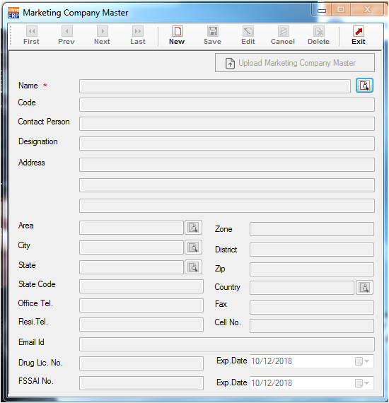

3. Validation list.

1. Duplicate Marketing Company Name. not allowed.
2. Empty Marketing Company Name not allowed.
3. If want upload Marketing Company list then click on “New button” and click on “Upload Marketing Company Master”.

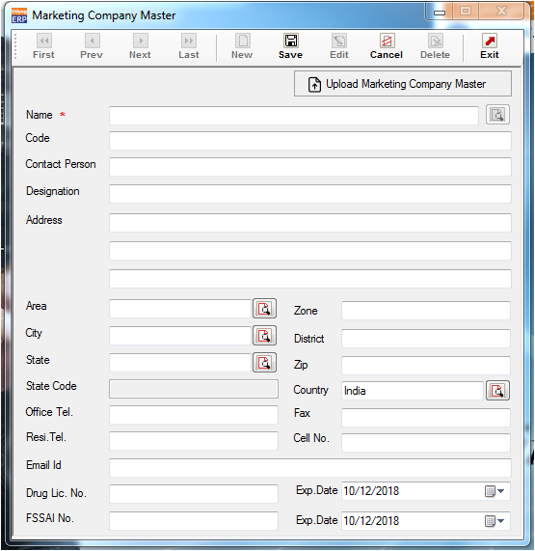

5.After click on “Upload Marketing Company Master”,Click on “Download Default Format”

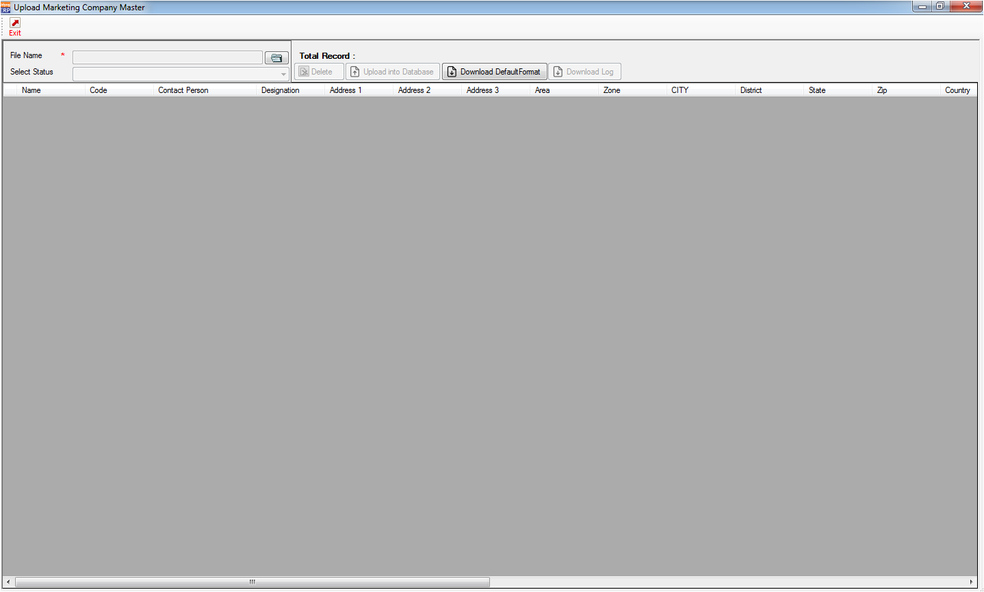

6.After Click on “Download Default Format”.

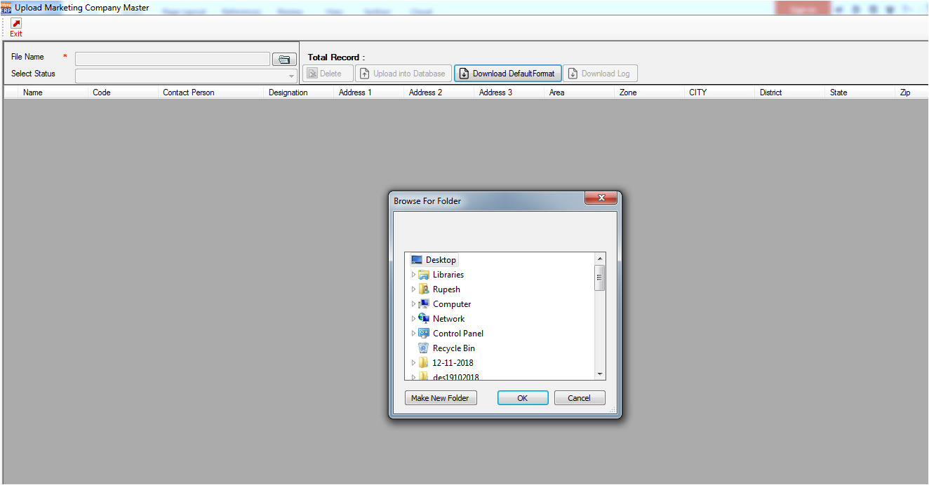

Select your folder and click on ok.

1. After click on “ok” Default excel format download selected folder.

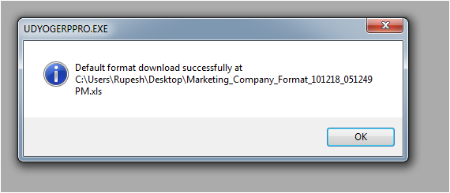

8.Add Marketing Company list in download format excel

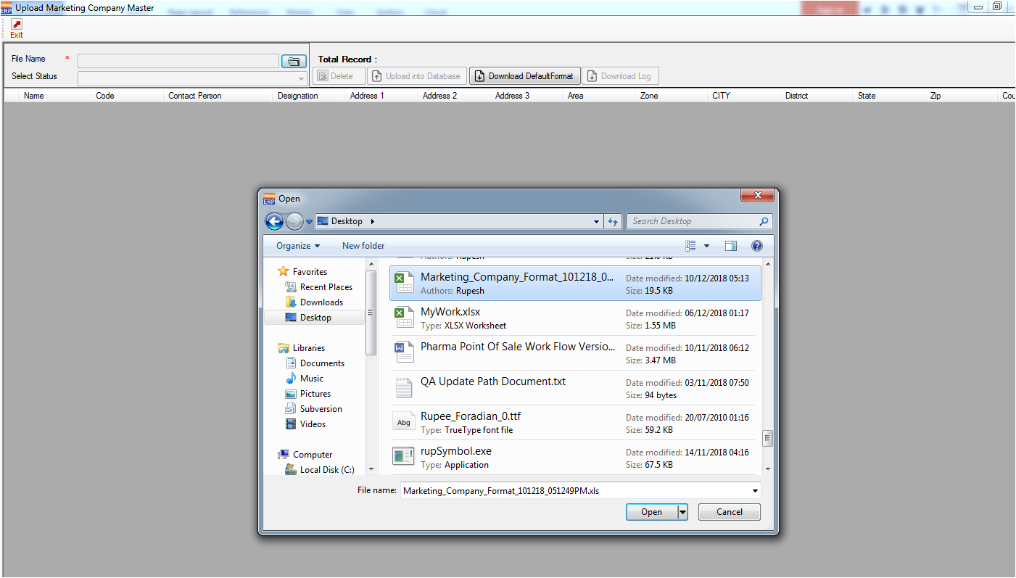

Select your excel.

9.After open excel.

1. If record already “Exist” in system then status become “Exist” and record colour is “LightBlue”.
2. If record is Duplicate in Grid then status become “Duplicate” and record colour is “LightBlue”.

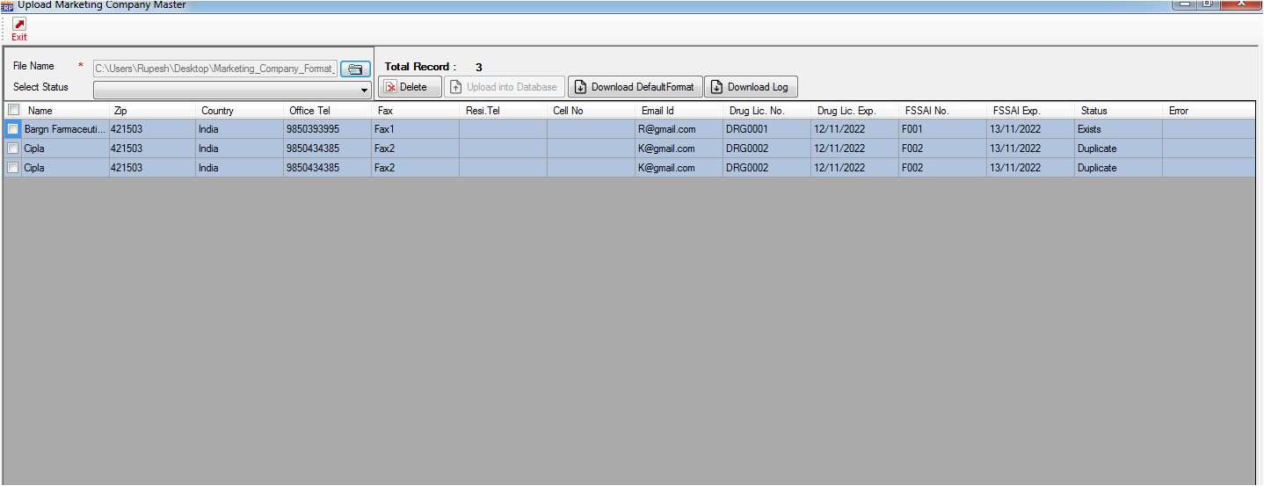

iii. Select your duplicate record and Click on delete button.

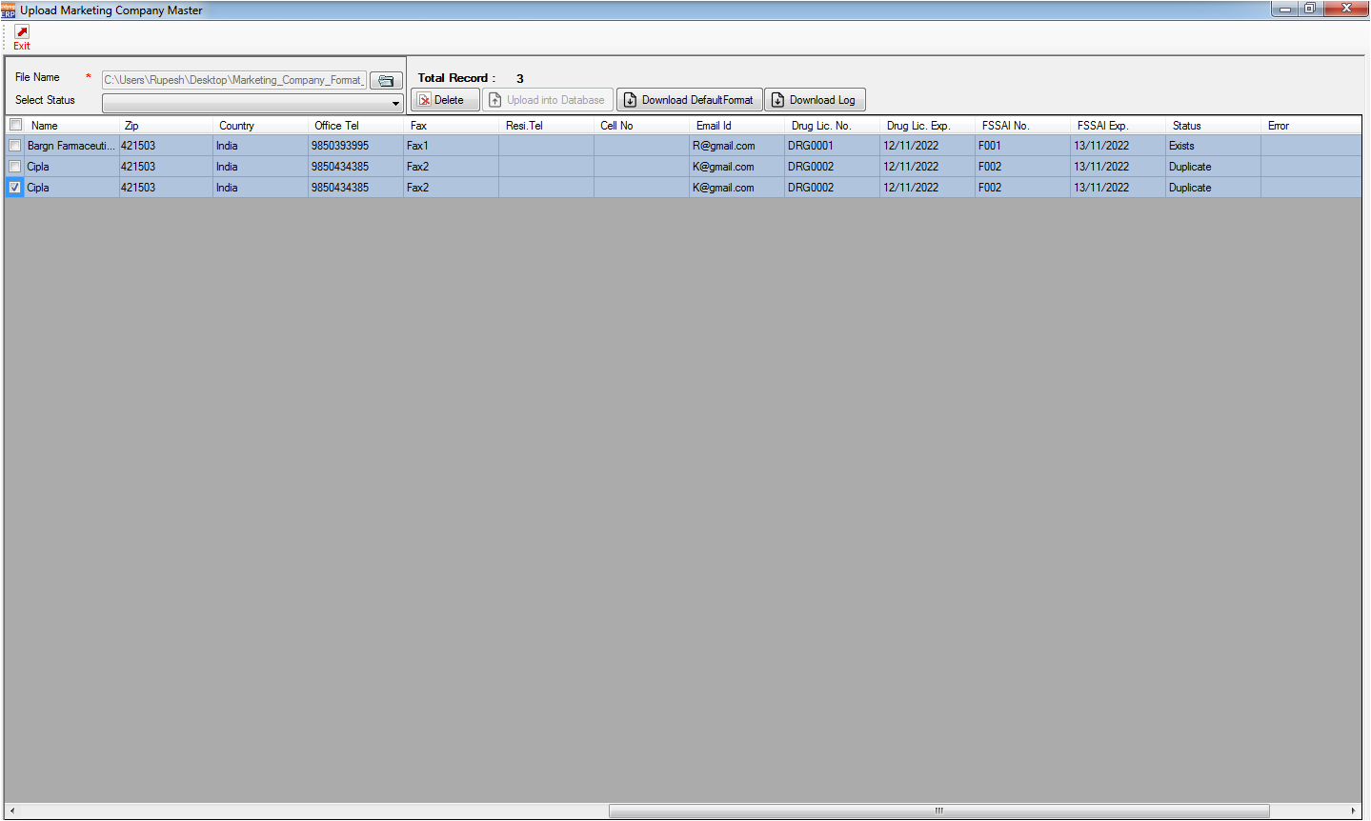

iv.After click on delete button,selected duplicate record was delete and status become change as “Deleted” and record colour is “LightPink”.

v.check once list with exist record if found new record then status become change as “New Record” and colour is light yellow.

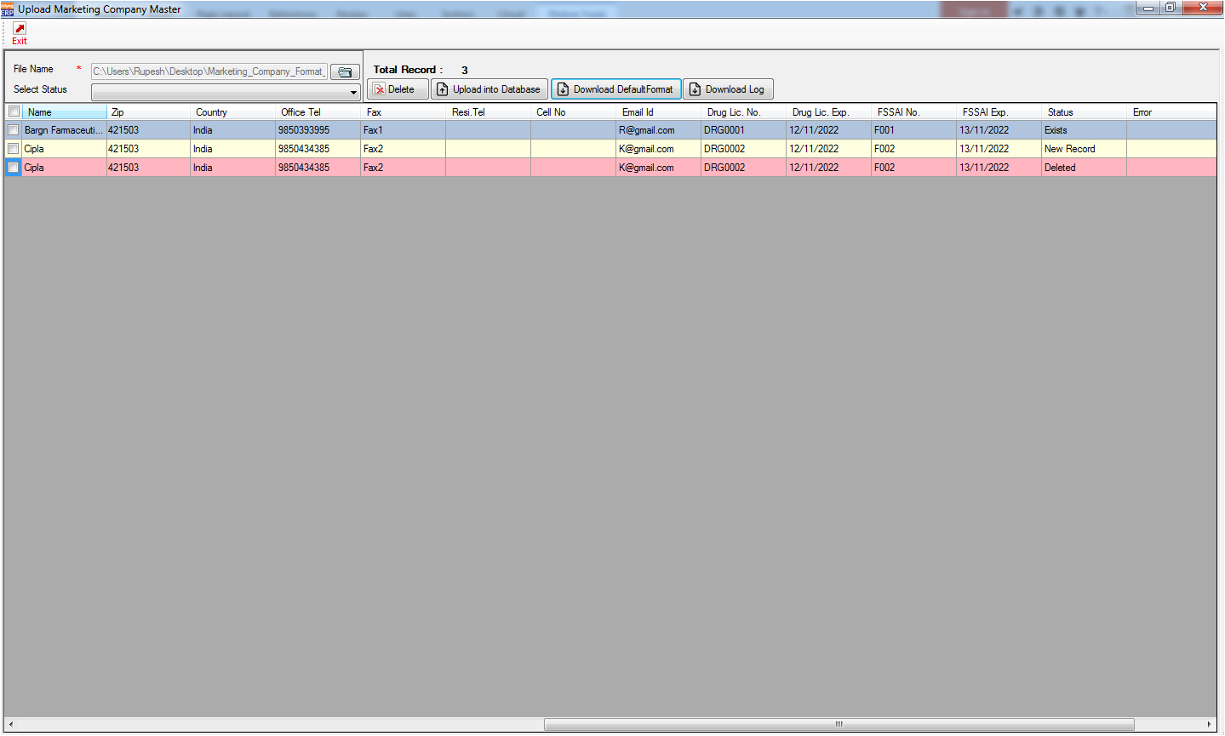

vi select your new record and click on “Upload into Database”,after click on “Upload into Database” then selected record insert into database and status become changed as “Inserted” and inserted record colour changed “Light green” .

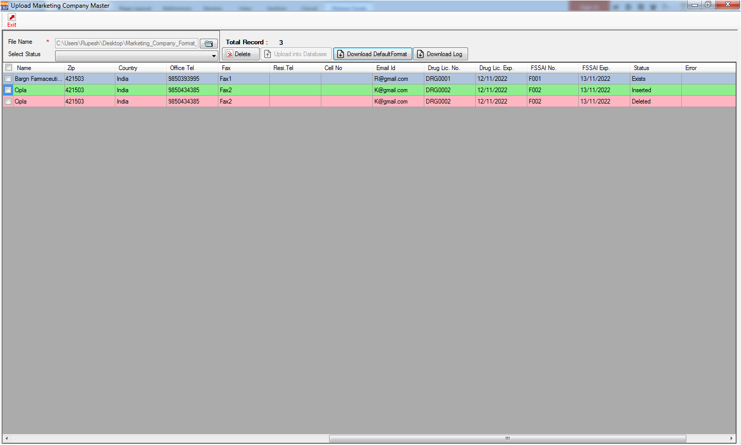

1. If want to Download log then click on “Download Log”,select your folder and download your log.

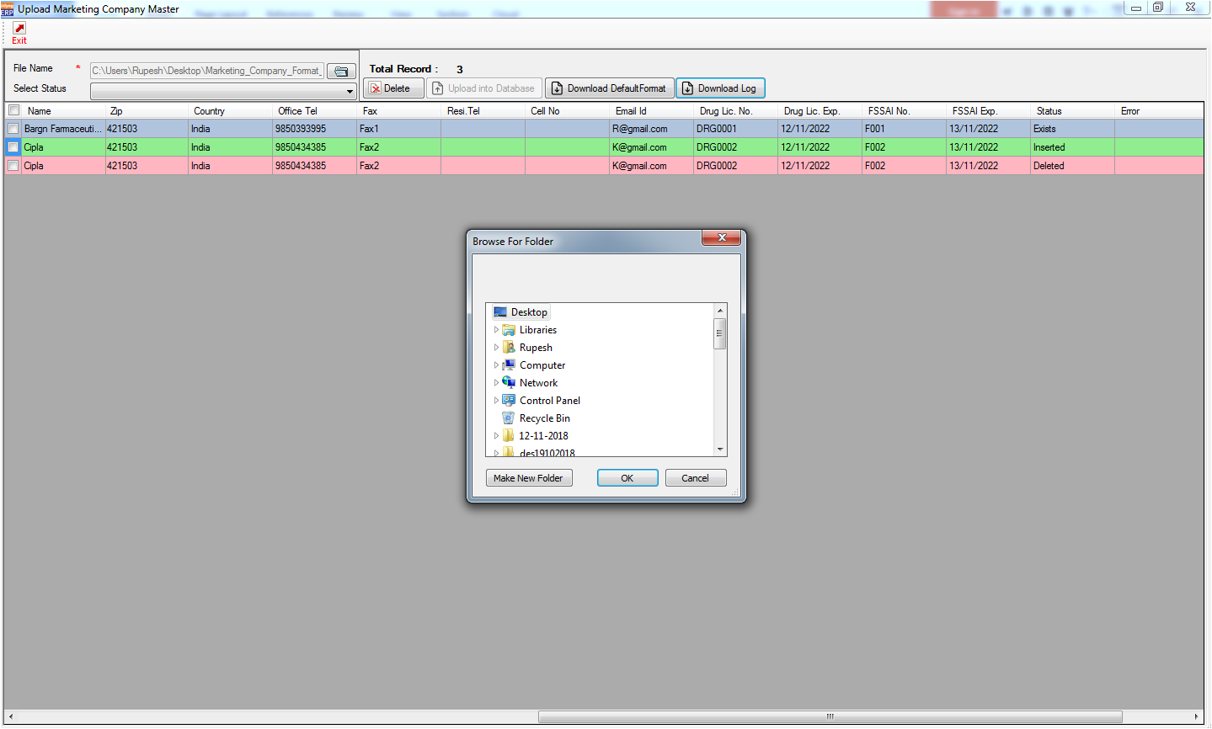

Select your folder and click on ok.

11.Download log excel file.

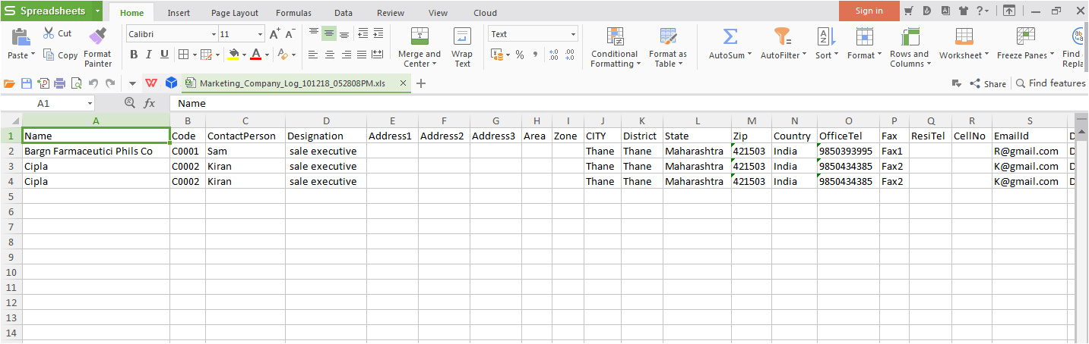

12.If status is “Not Inserted” in status column,then in error column show error message why data not inserted.

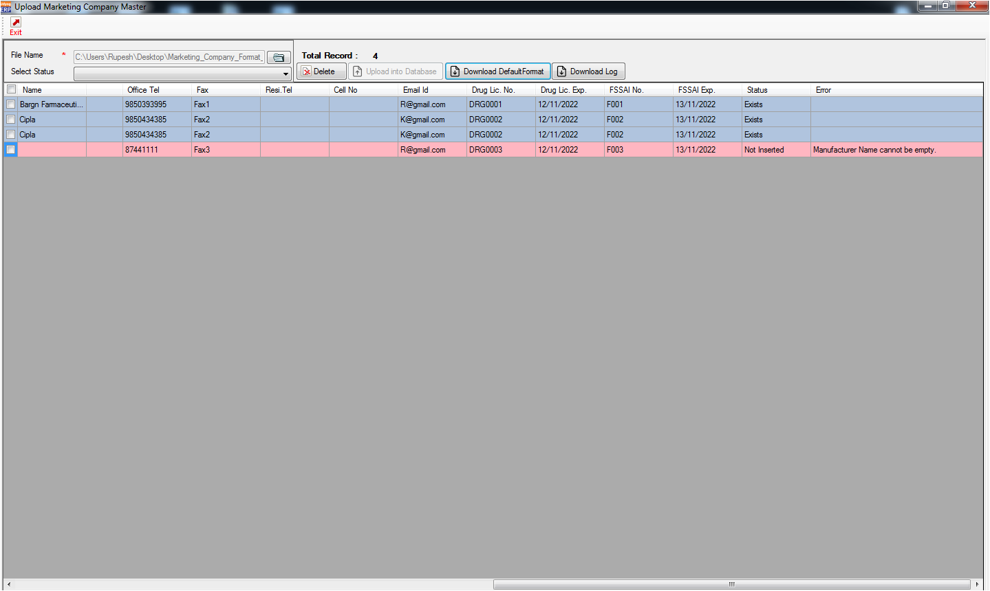

Validation List:-

1. Marketing Company Name cannot be empty..
2. Code sholud be less than or equal 10 Character.
3. State not found in default list.
4. Country not found in default list.
5. Zip sholud be numeric.
6. Enter valid Zip.
7. Office Tel sholud be numeric.
8. Resi Tel sholud be numeric.
9. Cell No sholud be numeric.
10. Email id is not Proper.
11. Drug Lic.Exp. Date invalid or blank.
12. FSSAI Exp. Date invalid or blank.